|  |
| --- |
| Bond & Pollard Ltd |
| Oracle Demo Application |
| Installation Guide |

|  |
| --- |
| Ian Bond  3-11-2025 |

Table of Contents

Introduction 3

Oracle Database Express (XE) 4

Installing Oracle XE 4

Managing Oracle 5

Starting the Oracle Services 5

Starting and Stopping the Database 7

Net Services Listener 8

Developer Tools 10

SQL*Plus 10

SQL Developer 13

The Demo Application 14

Database Security 14

Demo Schema 15

Users / Schemas 15

Applications 15

Packages 15

Tables 16

Source Code Templates 17

Directories 17

Installing the Demo Application 18

Getting Started 25

CSV File Import Demo 27

Application Development 34

Systems Development Life Cycle 35

Planning 35

Analysis 35

Design 36

Development 36

Testing 36

Implementation 37

Maintenance 37

Documentation 38

Release Management 39

Deployment Environments 39

Source Control Management 39

Modular Database Applications 40

Client Server Architecture 40

Database Design 41

Normalization 41

Surrogate vs Natural Keys 47

Constraints 49

Coding Standards 50

Golden Rules for Software Development 50

Naming Conventions 51

Coding Style 53

PL/SQL Programming Tips 54

Packages 55

Functions 55

Data Typing 56

Performance 56

# Introduction

The Demo Application has been developed as a working model of how to create a simple Oracle Database Application.

The application comprises:

* A single schema based on Oracle Education’s training database, known as the Scott schema.
* A setup.exe installer that generates then runs installation scripts that create the schema, load seed data and compile the packages.
* Additional tables and related objects to extend the functionality of the basic schema.
* A directory structure containing the sample application program source code, templates, installation and admin scripts, SQL reports and documentation.
* A simple application to import data into, and export data from the database using CSV files.
* PL/SQL Packages demonstrating useful functions.
* Source code templates.

The following documentation is included:

* A guide to creating an application development environment.
* A simple set of coding standards.
* A template technical specification document.
* Functional specifications.
* Technical specifications.
* A user guide for the data import application.

# Oracle Database Express (XE)

## Installing Oracle XE

The first task is to install Oracle Database Express, and SQL Developer, both of which can be downloaded from Oracle’s website.

Please refer to the [Database Express Installation Guide.](database-express-edition-installation-guide-microsoft-windows.pdf)

1. Login to your Oracle account on the Web.
2. Download Oracle XE for Windows.
3. Unzip the installation file.
4. Run setup.exe
5. Make a note of the connection strings.

**Tip: Store usernames and passwords securely in an encrypted database, such as Bitwarden.**

## Managing Oracle

### Starting the Oracle Services

The Oracle Database Services must be started prior to accessing the database and should start automatically when you start your computer.

The first pluggable database XEPDB1 opens automatically when the Oracle Database Service is started. Other pluggable databases remain closed by default and must be opened manually or set to open automatically.

To manage the Oracle Services, run the Windows Services app.

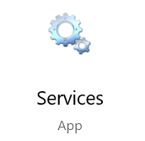

Search for the Oracle services, which should like the example below:

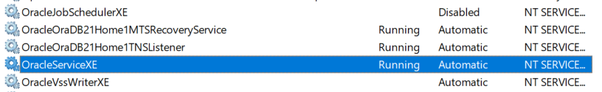

To start the Oracle Service, right-click on **OracleServiceXE,** and select Start.

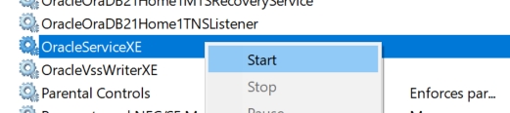

To set the start-up properties of a service, right-click, select properties and select Automatic, Manual or Disabled from the Startup type list.

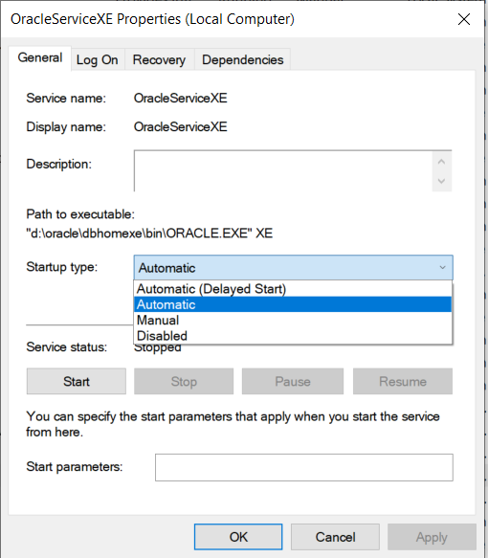

### Starting and Stopping the Database

#### Starting the Database via SQL*Plus

Run SQL*Plus from the command prompt, connect as SYSDBA:

**C:\> SQLPLUS / AS SYSDBA**

To start the database:

**SQL> STARTUP**

The first pluggable database should open automatically. To open all pluggable databases:

**SQL>ALTER PLUGGABLE DATABASE ALL OPEN**

#### Shutdown the Database via SQL*Plus

You should always shutdown the Oracle database before shutting down your computer, to prevent data corruption due to the file system suddenly being taken away from the running database.

To shut down the database:

**SQL>SHUTDOWN IMMEDIATE**

### Net Services Listener

The listener processes on a server detect incoming requests from clients for connection, by default on port 1521, and manage network-traffic once clients have connected to an Oracle database. The listener uses a configuration-file named **listener.ora** to help keep track of names, protocols, services and hosts.

You can start the listener using the Microsoft services app, or from the command prompt:

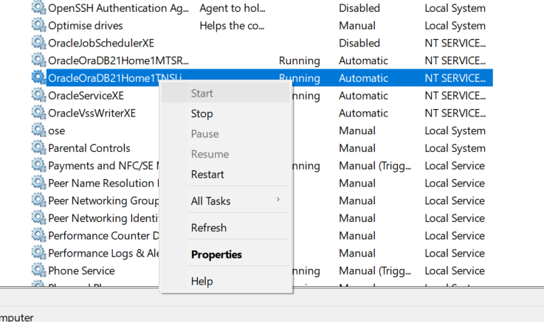

To check the listener status from the command prompt:

**C:\> LSNRCTL STATUS**

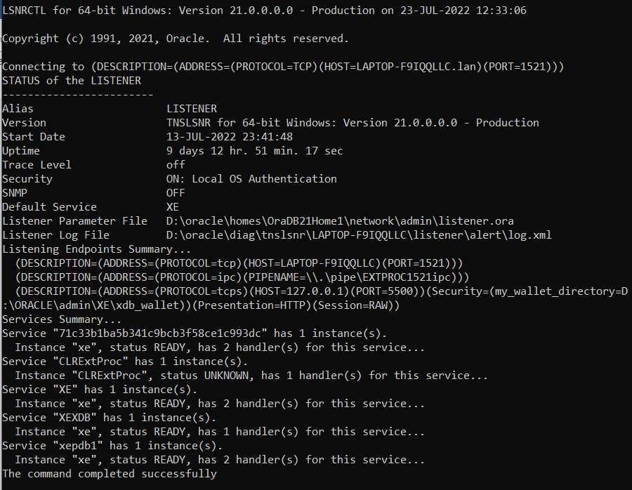

## Developer Tools

### SQL*Plus

The SQL*Plus tool runs from the Windows command prompt, with the following format:

Note that square brackets [ ] indicate optional parameters, angle brackets < > are required.

**C:\> SQLPLUS <USERNAME>/<PASSWORD>@//<HOSTNAME>[:PORT]/<DBNAME> [AS SYSDBA]**

|  |  |
| --- | --- |
| <username> | Database username, e.g. SYS |
| <password> | Password you specified during installation |
| <hostname> | Name of the database server, or its IP address. To reference the current computer, you can use *localhost.* |
| [:port] | Must be specified if the listener is not configured to use the default port 1521 |
| <dbname> | XE for the container  XEPDB1 for the first pluggable database |
| [AS SYSDBA] | This is required for the SYS user, otherwise you get the error “SP2-0157: unable to CONNECT to ORACLE after 3 attempts, exiting SQL*Plus” |

If you are a database administrator running SQL*Plus on the database server, you can connect to the container database directly by running the following command.

**C:\> SQLPLUS / AS SYSDBA**

Connect to container database XE

**C:\> SQLPLUS SYS/<PASSWORD>@//LOCALHOST:1521/XE AS SYSDBA**

**C:\> SQLPLUS SYS/<PASSWORD>@//LOCALHOST/XE AS SYSDBA**

**C:\> SQLPLUS SYS/<PASSWORD>@//192.168.1.225:1521/XE AS SYSDBA**

Connect to first pluggable database XEPDB1

**C:\> SQLPLUS SYS/<PASSWORD>@//LOCALHOST:1521/XEPDB1 AS SYSDBA**

**C:\> SQLPLUS SYS/<PASSWORD>@//LOCALHOST/XEPDB1 AS SYSDBA**

**C:\> SQLPLUS SYS/<PASSWORD>@//192.168.1.225:1521/XEPDB1 AS SYSDBA**

Check which database you are connected to:

**SQL> SHOW CON_NAME**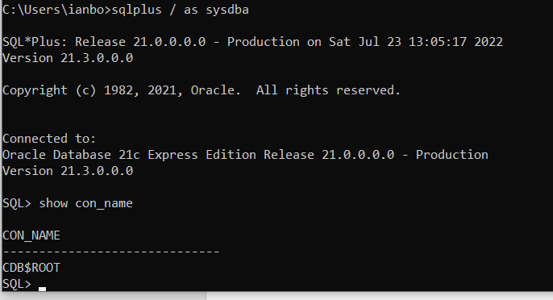

To switch to the first pluggable database:

**SQL> ALTER SESSION SET CONTAINER=XEPDB1;**

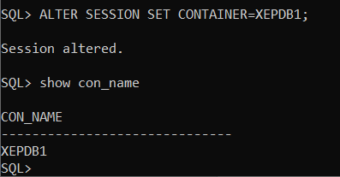

To switch to the container database:

**SQL> ALTER SESSION SET CONTAINER=CDB$ROOT;**

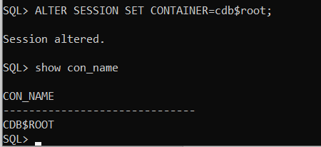

### SQL Developer

Download the SQL Developer tool from the Oracle website.

Create a connection for the SYS user, with role SYSDBA.

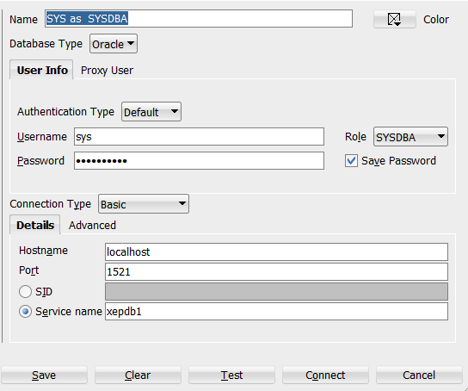

**Tip: Restrict access to the SYS user and store the password securely in an encrypted database.**

# The Demo Application

## Database Security

The worst, and most commonly occurring security mistake is to have all your database objects in one schema and then give all your users and applications the schema’s password. This is an extremely dangerous thing to do. Anybody could connect to your schema and start dropping tables or changing the table structures.

Instead:

* Create a schema that owns all the database objects, the Owning Schema, that no users or applications ever connect to.
* Prevent users from connecting to the Owning Schema. Lock the account and turn off authentication so no clues are given that the account exists. If someone tries to logon, they will get an invalid username/password error instead of a message saying the account is locked, which would give away its existence, and importance.
* Create a secondary schema for the users to connect to the database with, that has limited privileges, and the necessary grants to access objects in the Owning Schema.

This simple approach will prevent users from truncating and dropping tables. If you are giving privileges such as delete and update, there is a risk that people could alter the data, but at least you have prevented structural changes to the database.

## Demo Schema

The demo application database schema is based on Oracle Education’s Scott schema, with some additional features and sample PL/SQL applications.

### Users / Schemas

|  |  |
| --- | --- |
| **User Name** | **Description** |
| appsdemo | This is the owning schema, which contains all the demo database objects. No users or applications must ever connect to the database as this user, as it would be a major security risk. |
| demo_connect | This user has the minimal privileges, and grants to the appsdemo schema, necessary to run the demo applications. |

### Applications

|  |  |
| --- | --- |
| **Application** | **Description** |
| CSV Data Import | Import data from CSV files into the database. A simple demo has been provided, along with a sales order import that has more complex validation. |
| CSV Data Export | Export data to CSV file. A simple demo, and a sales order export have been provided. |

### Packages

The following packages have been provided.

|  |  |
| --- | --- |
| **Package Name** | **Description** |
| EXPORT | Export data (orders) to CSV files. |
| IMPORT | Import data from CSV files with validation and error handling. Includes order import and a simple demo. |
| ORDERRP | Rules package for Order related functions, for example *currentprice* returns the price that is currently in effect for a product. This saves repeating code and makes maintenance easier. |
| PLSQL_CONSTANTS | Define non-table related data types and constants such as directory names, delimiter characters. |
| UTIL_ADMIN | Admin functions such as standardised error handling. |

|  |  |
| --- | --- |
| **Package Name** | **Description** |
| UTIL_DATE | Date manipulation functions. Date of Easter and related holidays. Is date a working day? Last working day of month. |
| UTIL_FILE | Load data from an external CSV file into a staging table. |
| UTIL_NUMERIC | Number manipulation functions. Base conversion, factorial, sort numbers, convert integer to an alphabetic code. |
| UTIL_STRING | String handling functions. Extract fields from a delimited string (used by CSV import function), sort strings, convert escaped characters to formatting characters (\n becomes New Line ASCII character 10). |

### Tables

#### Oracle Demo

|  |  |
| --- | --- |
| **Table Name** | **Description** |
| BONUS | Employee salary, commission |
| CUSTOMER | Customer table |
| DEPT | Departments |
| DUMMY | Demo table of numbers used for SQL exercises |
| EMP | Employees |
| ITEM | Item (order lines) table |
| ORD | Order table (order lines in associated ITEM table) |
| PRICE | Product prices. Minimum, Current price effective start and end date. |
| PRODUCT | Product table, foreign key reference by ITEM |
| SALGRADE | Employee job grade salary ranges |

#### Demo Application

|  |  |
| --- | --- |
| **Table Name** | **Description** |
| APPLOG | Application message log: messages with a severity, timestamp, user and program name. |
| APPSEVERITY | Application message severity: Info, Warning, Error |
| COUNTRY | Maintain a list of valid country codes. |
| COUNTRY_HOLIDAY | Maintain holiday dates by country and year. Used by the date functions to calculate working days: last working day of month, number of working days between two dates etc. |
| DEMO | Simple table with a date and text column, used to demonstrate data import/export functions. |
| IMPORTCSV | Staging table for CSV data to be imported into the database. Function *util_file.load_csv* loads CSV data into this table. Data fields are in a delimited string “field1”,field2,field3,”field4” etc. |
| IMPORTERROR | When importing CSV data, it will be validated and all errors logged here. Separate from the application log to make it easier to report and manage. |

### Source Code Templates

|  |  |
| --- | --- |
| **Source Type** | **Template** |
| DOS Batch file | [..\templates\dos script.bat](../templates/dos%20script.bat) |
| PL/SQL Package Body | [..\templates\pkg_template_body.pkb](../templates/pkg_template_body.pkb) |
| PL/SQL Package Specification | [..\templates\pkg_template_spec.pks](../templates/pkg_template_spec.pks) |
| SQL script | [..\templates\sql_template.sql](../templates/sql_template.sql) |

### Directories

|  |  |
| --- | --- |
| **Directory Name** | **Contents** |
| admin | Database admin scripts. Start database. Create users. Check for invalid objects. |
| bin | Binaries. Executable images (compiled programs) |
| com | DOS batch scripts. |
| config | Configuration files. You must edit these to specify the database service name, application owner (schema), and directory paths. |
| data | Data (import and export files) |
| documentation | Systems documentation, specifications, user guides |
| install | Scripts to automatically install the database schema, load seed data and compile packages |
| log | Program logs |
| out | User report output |
| plsql | Package source code |
| sql | SQL scripts: reports, scripts to execute package code |
| src | Program source code, e.g., C source files |
| templates | Code templates |
| test | Scripts and SQL to test programs, automated test scripts |

## Installing the Demo Application

Download the archive file containing the demo application from the Bond & Pollard website:

<http://www.bondpollard.co.uk/documents/appsdemo.zip>

The appsdemo.zip file will be downloaded to your PC downloads folder.

Right-click on appsdemo.zip and select Extract All.

Click on the Extract button. The following directories will be created under appsdemo: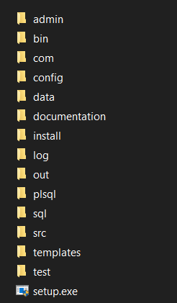

Go to the appsdemo folder and double-click on **setup.exe** to run the installer.

A User Account Control windows will be displayed asking you to confirm you want to run the program. Click the YES button.

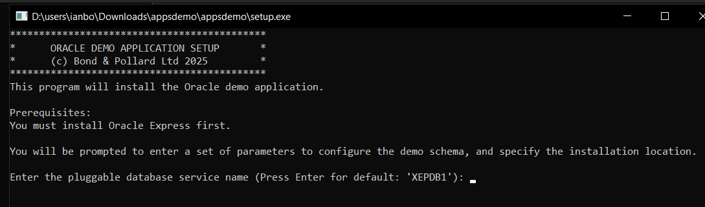

Press ENTER to accept the default for the database service XEPDB1, the default first pluggable database.

Enter *mydemo* as the name of the application owner. The application owner is the user who owns all the database schema objects such as tables. Access must be strictly controlled to this user.

Enter *mydemo_connect* as the name of the connection user. This user has limited privileges and will be used to run the application.

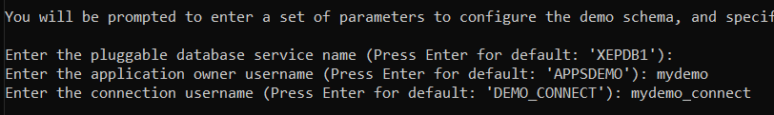

Press *enter* to accept the default database listener port 1521:

Next you will be prompted for APP_HOME directory. This directory contains all the SQL scripts and programs.

***The directory must exist, so create it before continuing.***

We will specify the directory **d:\test_app**

Next you will be prompted for the APP_DATA directory. This directory contains external files such as CSV files used for data import to the database.

***The directory must exist, so create it before continuing.***

**IMPORTANT: This directory path must not contain spaces or special characters such as &.**

We will specify the directory **d:\test_user_data**

The setup parameters will be displayed for you to check:

**Make a note of the names of APP_OWNER and CONNECT_USER. You will need these to connect to the database.**

You will be prompted to confirm that you want to continue with the installation. Enter Y.

Progress bars will be displayed as the APP_HOME and APP_DATA directories are created.

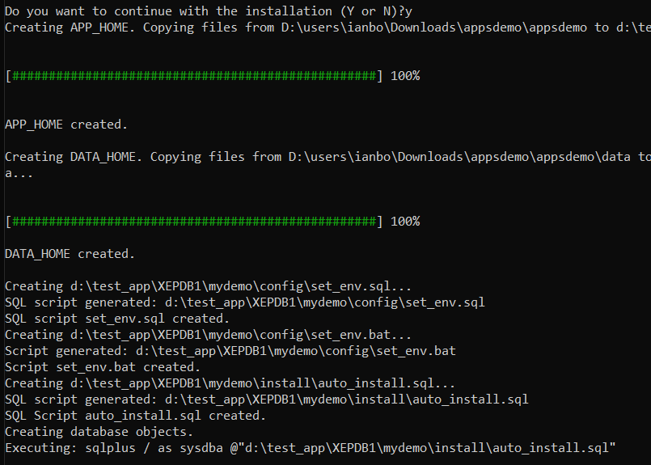

The following scripts are created automatically using the parameters you specified:

* Set_env.sql – sets parameters for sql scripts that run from the command line.
* Set_env.bat – sets parameters required for batch programs that run at the command prompt.
* Auto_install.sql – this SQL script runs automatically to create the database schema objects, load seed data into the tables, and compile the PL/SQL packages.

SQL*Plus runs the auto_install.sql script to create the database objects. You will be prompted to enter the password for the application owner *mydemo.* I have chosen *tiger* the name of Bruce Scott’s cat.

**TIP:** Record the app owner and password in a secure encrypted app such as Bitwarden.

Next you will be asked to specify a password for the connection user *mydemo_connect.*

**TIP:** Record the connect username and password in a secure encrypted app such as Bitwarden.

You will be prompted for the SYS password that you created earlier when you installed Oracle.

Enter the SYS password and press enter. The script will then proceed to create the database objects, load data into tables, and compile packages.

A summary will be displayed.

A log file called *install.log* is created in the download directory which you can check for errors.

Press *enter* to exit from the installer.

A shortcut named as the app owner will be created on the desktop. You can click on this to start the database and open the command line, with the environment configured for your Oracle app.

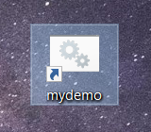

The installation program should have done the following:

* Create directories:
  + APP_HOME
  + DATA_HOME
* Create configuration scripts:
  + Set_env.sql
  + Set_env.bat
  + Auto_install.sql
* Install schema:
  + Create Owner Schema
  + Create database connection user
  + Create database directories
  + Create sequences
  + Create tables and indexes
  + Grant table access privileges to connection user
  + Create synonyms for tables
* Seed data:
  + Load data into tables
* Compile PL/SQL packages:
  + Compile packages
  + Grant execute privileges to connection user
  + Create synonyms for packages
* Lock schema:
  + Lock the Owner Schema, and set no authentication to keep it secure

Launch SQL Developer and create a connection for *mydemo_connect:*

Username: mydemo_connect

Password: (the password you specified during installation)

Service name: check the radio button, and enter XEPDB1.

Click Test to check the connection works, then click save.

## Getting Started

Click on the desktop icon to start Oracle and get to the command prompt.

The command prompt is set as **XEPDB1\mydemo>**

To run SQL*Plus enter the command:

**sqlplus mydemo_connect/*password*@//localhost/xepdb1**

## CSV File Import Demo

In this demonstration we will:

1. Attempt to import order data from a CSV file which contains several errors.
2. Run a report to find out what the errors were.
3. Fix the errors in the CSV file.
4. Run the import process again with the corrected CSV file.
5. Run an order report to view the newly imported orders.

For this demonstration we will use the test order file ***order_data 017 ERRORS.csv*** which is the in the *data\pending* directory. Note that this file contains a number of errors, so the import will fail.

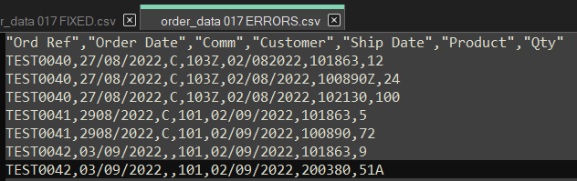

Copy the CSV file from the data directory Pending to Received.

Click on the desktop shortcut.

Run the *import_order* batch program. Enter the following commands at the prompt:

You will be prompted to enter the password for *mydemo_connect.*

Enter the password that you specified during installation.

The program reported that there were errors importing the file *order_data 017 ERRORS.csv.*

To investigate further, open SQL Developer, connect to my*demo_connect*, then open and run the SQL script ***applog.***

Note the error messages reported for the order file we tried to import.

To view the detailed error messages, run the report ***import_errors.sql.***

Note that Key Value refers to the Order Reference field in the CSV file. The CSV data is shown against each error message so you can identify the row in the CSV file that needs to be fixed.

The following errors have been reported:

* TEST0040: Customer ID 103Z is invalid – the Z on the end should not be there, so the customer cannot be found.
* TEST0040: Ship Date 02/08/2022 is earlier than the order date. To correct this error, we need to change it to a date on or after the order date 27/08/2022.
* TEST0040: Product 100890Z invalid – the Z on the end should not be there, so the product cannot be found.
* TEST0042: Ship Date 02/09/2022 is earlier than the order date. To correct this error, we need to change it to a date on or after the order date 03/09/2022.
* TEST0042: Qty 51A invalid number. Just remove the A from the end.

To fix the errors:

1. Find the CSV file in the error directory DATA_IN\error.
2. Edit the file and correct the above errors.
3. Move the file to the Received directory. For this demonstration, we will also rename the file to ***order_data 017 FIXED.csv***
4. Run the *import_order* program again, and check for errors.

Editing the file to correct the reported errors:

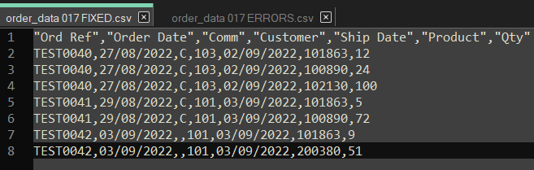

Run the *import_order* process again.

Enter the password for *mydemo_connect* when prompted.

Note that this time we see the message **“Success!”.**

Run the import_errors.sql report again. This time, there should be no errors reported for the orders in the CSV file.

Finally, run the orders report, ***orders_param.sql.*** Specify the range of orders to report as TEST0040 to TEST0042:

The orders in the CSV file have now been successfully loaded into the database.

# Application Development

You should consider the following before starting to develop your applications:

**Systems Design**

* Choose a systems development methodology, for example the Oracle Unified Method.

**Data Security**

* Lock the owning schema, and provide connection only users with limited privileges.
* Passwords to be encrypted, never hardcoded in scripts.
* General Data Protection Regulation GDPR
* Segregation of duties
* Backup & Disaster Recovery

**Change Management**

* Managing changes:
  + Support Ticket / Change Request / Asset management (Samanage, SolarWinds Service Desk).
* Documenting changes to your database and application.

**Software Development**

* Create separate database environments for development, testing and production.
* Source Control Management: Subversion, Git.
* Determine how you will document your applications. At the very least you should document all of your [package public functions and procedures](../templates/pkg_template_spec.pks). Include comments in the package specification that describe how to use each procedure and function.
* Database design
  + Normalization.
  + Surrogate or Natural keys.
  + Constraints to enforce business rules and data integrity.
* Coding standards, based on software engineering best practice.
  + Naming conventions for your database objects and applications.
* Building packages/libraries of commonly used functions and procedures:
  + Business functions
  + Rules Packages
  + Constants
  + Error handling

## Systems Development Life Cycle

The Systems Development Life Cycle (SDLC) is the process by which information systems are created or modified.

The SDLC has the following stages:

1. Planning
2. Analysis
3. Design
4. Development
5. Testing
6. Implementation
7. Maintenance

It is best to take an iterative approach to the SDLC. Do some analysis, then some design and implementation, and feed-back what you learn into the analysis stage, and so on.

### Planning

Study the feasibility of creating or changing a system to meet the needs of the business. Consider the benefits of the new system versus the resources, time and cost involved.

Whilst the proposals may be technically possible, you must consider the business case, and identify potential problems. For example, it may be feasible to configure a warehouse management system to provide lot control, bringing benefits to the customer, however increased administration costs may not have been considered in the contract, leading to financial losses.

### Analysis

Gather the requirements of the business, and users of the system. Consider the functionality of the new system. Analyse the requirements to select a solution that best fits the business needs.

* Research and describe the operation of the current business system
* Understand the problems of the current system, and the reasons why a new system is required
* Define and document the requirements of the new system.

### Design

Create a detailed functional specification for the system. Work with the users to define their requirements, and identify all the information that needs to be processed. Consider the hardware, networking and software requirements.

* Decide on a design strategy
* Pick an appropriate solution
* Produce a detailed specification
  + Data Model / Entity Relationships Diagrams
  + Process Model / Data Flow Diagrams
* Consider a strategy for support of the system once it has been implemented

### Development

Design and build the database using the data model. Write technical specifications for the processes. Develop the software application programs.

* Database creation and population
* Technical Specifications
* Program Design
* Programming

### Testing

Test the system to ensure it meets the defined requirements, is free from errors, robust and performs to the required standard.

The testing will be carried out by quality assurance professionals, and the end users. When the end users are satisfied with the system it can be signed off as ready to move into production, or go live.

### Implementation

The new database and software applications are moved into a live “production” environment. A plan must be in place to revert to the old system if problems are encountered during implementation.

* Preparation of user documentation
* User training
* Implement system support strategy

### Maintenance

The system will require support and upgrades during its lifetime. Faults may need to be fixed, or new requirements will be identified, necessitating changes to the system.

## Documentation

You will need to create, update and manage the documentation for your applications.

Oracle use the following document templates for application extensions:

* [MD050 Application Extension Functional Design](MD050_Application_Extensions_Functional_Design.docx)
* [MD070 Application Extension Technical Design](MD070_Application_Extensions_Technical_Design.docx)

You will also need the following documents:

* Planning / Feasibility Study
* Requirements Analysis
* Data Model: Entity Relationship Diagrams
* Process Model: Data Flow Diagrams
* Coding Standards
* PL/SQL Libraries
* Application Programming Interfaces
* User Guide
* Test Plans
* Release Control (with instructions for how to deploy the applications into production)

## Release Management

Software applications are developed, tested and deployed into product via a structured release management process. This process allows for changes to be rolled back if there are any problems, to maintain the integrity of the live system.

### Deployment Environments

The following environments are used:

* DEV is the development environment where all new software is created and where changes are made to existing applications
* TEST is the environment where all the testing, including user acceptance tests, takes place.
* PROD is the live Production environment

Additional environments such as SANDBOX may be created for testing patches, upgrades and other major changes to the system.

## Source Control Management

Source Control Management tools allow you track and manage changes to software.

The source code is stored in a repository, which retains a history of each version as changes are made. Developers check out code to work on, and check the new version of the source code back into the repository when it is ready to be deployed into the production system.

## Modular Database Applications

The following abstract is taken from Bryn Llewellyn’s White Paper: [White Papers\why_use_plsql_whitepaper_10.pdf](White%20Papers/why_use_plsql_whitepaper_10.pdf)

Large software systems must be built from modules. A module hides its implementation behind an interface that exposes its functionality. This is computer science’s most famous principle.

For applications that use an Oracle Database, the database is, of course, one of the modules. The implementation details are the tables and the SQL statements that manipulate them. These are hidden behind a PL/SQL interface. This is the Thick Database paradigm: *select, insert, update, delete, merge, commit, and rollback* are issued only from database PL/SQL. Developers and end-users of applications built this way are happy with their correctness, maintainability, security, and performance. But when developers follow the noPLSQL paradigm, their applications have problems in each of these areas and end-users suffer.

Do not build your business rules into individual programs or database triggers, as this will lead to duplication, inconsistency, and make maintenance extremely difficult and time consuming. Instead, build your business processes into database packages. The packaged functions and procedures will perform all the necessary SQL actions described above. Call the packaged functions from database triggers and application programs as required.

For example, let us say you have a function that checks a customer’s credit status, and returns their account balance. You may want to perform this check in several places: before accepting a new order, when printing a customer account report, and so on. Rather than having the function coded separately in different programs, it is far better to do it once in a single packaged function that can be called whenever necessary.

## Client Server Architecture

Hide the implementation from the client applications

Build your business logic into packages of procedures and functions that reside in the database. Your client programs will call these stored procedures whenever they need to retrieve, insert or modify data – the client programs themselves should not communication directly with the database.

## Database Design

### Normalization

Normalization is the process of organizing a database to remove redundant, duplicated data, and to group related items together to allow efficient storage, retrieval and modification of data.

Edgar F Codd invented the Relational Model for databases in the early 1970s, and together with Raymond F Boyce defined Boyce-Codd Normal Form BCNF.

The following example describes the process of converting non-relational order data stored in a spreadsheet into a set of normalized relational database tables.

The following table represents how non-normalized order data is stored in a spreadsheet.

|  |  |  |  |  |  |  |  |  |  |
| --- | --- | --- | --- | --- | --- | --- | --- | --- | --- |
| **Order ID** | **Order Date** | **Cust ID** | **Name** | **Item ID** | **Product ID** | **Description** | **Price** | **Qty** | **Total** |
| 601 | 01-MAY-86 | 106 | Shape Up | 1 | 200376 | SB ENERGY BAR-6 PACK | 2.40 | 1 | 2.40 |
| 604 | 15-JUN-86 | 106 | Shape Up | 1 | 100890 | ACE TENNIS NET | 58.00 | 3 | 174.00 |
|  | | | | 2 | 100861 | ACE TENNIS RACKET II | 42.00 | 2 | 84.00 |
| 3 | 100860 | ACE TENNIS RACKET I | 44.00 | 10 | 440.00 |
| 610 | 07-JAN-87 | 101 | TKB Sport Shop | 1 | 100860 | ACE TENNIS RACKET I | 35.00 | 1 | 35.00 |
|  | | | | 2 | 100870 | ACE TENNIS BALLS 3-PACK | 2.80 | 3 | 8.40 |
| 3 | 100890 | ACE TENNIS NET | 58.00 | 1 | 58.00 |

Note:

* An order can have one or more associated products.
* The columns containing product information are repeated.
* The product columns have been wrapped to fit on the page, but imagine them being all on a single row for each order.

#### First Normal Form

***A relation is in first normal form if it conforms to the following rule:***

* ***Each row, or record, in your database table must be uniquely identified by a Primary Key, with no repeating groups of fields.***

In our example, the Product ID, Description, Price, Qty and Total columns are repeated several times for each order.

There are several problems with this organization of the data:

* A customer may order 1, 2, 10 or more products. Your database table would need multiple sets of columns to store the product information for each order.
* You will be restricted as to how many products a customer can order at one time depending on how many columns you created in your table.
* You could potentially waste a lot of space in your database if you provide columns for 10 products per order, but customers typically order one or two items each time.

To make the database comply with First Normal Form we must split the repeating product information into separate rows, each uniquely identified by a key comprising one or more columns.

|  |  |  |  |  |  |  |  |  |  |
| --- | --- | --- | --- | --- | --- | --- | --- | --- | --- |
| **ORDID (Primary Key part 1)** | **ORDERDATE** | **CUSTID** | **NAME** | **ITEMID (Primary Key part 2)** | **PRODID** | **DESCRIPTION** | **ACTUALPRICE** | **QTY** | **TOTAL** |
| 601 | 01-MAY-86 | 106 | Shape Up | 1 | 200376 | SB ENERGY BAR-6 PACK | 2.40 | 1 | 2.40 |
| 604 | 15-JUN-86 | 106 | Shape Up | 1 | 100890 | ACE TENNIS NET | 58.00 | 3 | 174.00 |
| 604 | 15-JUN-86 | 106 | Shape Up | 2 | 100861 | ACE TENNIS RACKET II | 42.00 | 2 | 84.00 |
| 604 | 15-JUN-86 | 106 | Shape Up | 3 | 100860 | ACE TENNIS RACKET I | 44.00 | 10 | 440.00 |
| 610 | 07-JAN-87 | 101 | TKB Sport Shop | 1 | 100860 | ACE TENNIS RACKET I | 35.00 | 1 | 35.00 |
| 610 | 07-JAN-87 | 101 | TKB Sport Shop | 2 | 100870 | ACE TENNIS BALLS 3-PACK | 2.80 | 3 | 8.40 |
| 610 | 07-JAN-87 | 101 | TKB Sport Shop | 3 | 100890 | ACE TENNIS NET | 58.00 | 1 | 58.00 |

* The columns have been renamed to follow our database object naming rules.
* Each row can be identified by a unique Primary Key comprising the *ORDID* plus ITEMID.

#### Second Normal Form

***A relation is in second normal form if it conforms to the following rules:***

* ***It is in first normal form.***
* ***Each column, or field, in the record must depend on the whole Primary Key and not just part of it.***

The columns ORDERDATE, CUSTID and NAME are duplicated in several rows, as they are dependent on only part of the Primary Key, ORDID. To resolve this problem, we need to create a new table *ORD* that will hold a single row for each unique order.

**ORD**

|  |  |  |  |
| --- | --- | --- | --- |
| **ORDID**  **(Primary Key)** | **ORDERDATE** | **CUSTID** | **NAME** |
| 601 | 01-MAY-86 | 106 | Shape Up |
| 604 | 15-JUN-86 | 106 | Shape Up |
| 610 | 07-JAN-87 | 101 | TKB Sport Shop |

There are still a number of problems with this new table:

* The customers’ names are repeated on multiple rows.
* If a customer’s name changes, and not all rows are updated, there will be inconsistencies in the database.

The remaining columns will be placed in a new table called ITEM.

**ITEM**

|  |  |  |  |  |  |  |
| --- | --- | --- | --- | --- | --- | --- |
| **ORDID (Primary Key Part 1)** | **ITEMID (Primary Key Part 2)** | **PRODID** | **DESCRIPTION** | **ACTUALPRICE** | **QTY** | **TOTAL** |
| 601 | 1 | 200376 | SB ENERGY BAR-6 PACK | 2.40 | 1 | 2.40 |
| 604 | 1 | 100890 | ACE TENNIS NET | 58.00 | 3 | 174.00 |
| 604 | 2 | 100861 | ACE TENNIS RACKET II | 42.00 | 2 | 84.00 |
| 604 | 3 | 100860 | ACE TENNIS RACKET I | 44.00 | 10 | 440.00 |
| 610 | 1 | 100860 | ACE TENNIS RACKET I | 35.00 | 1 | 35.00 |
| 610 | 2 | 100870 | ACE TENNIS BALLS 3-PACK | 2.80 | 3 | 8.40 |
| 610 | 3 | 100890 | ACE TENNIS NET | 58.00 | 1 | 58.00 |

* Each row on item is uniquely identified by a primary key consisting of ORDID plus ITEMID.
* ORDID is a Foreign Key, referencing the ORD table ORDID column.
* The product descriptions are repeated in multiple rows.

#### Third Normal Form

***A relation is in third normal form if it conforms to the following rules:***

* ***The database must conform to the second normal form rules.***
* ***No column must depend on any other column except the Primary Key.***

If a column is uniquely identified *through one or more other columns in addition to the primary key*, this is known as transitive dependence, and breaks the rules of third normal form.

The name of the customer associated with each order depends directly on the CUSTID, not on the Primary Key, ORDID. We need to create a new table to hold the customer information, which will eliminate the duplication of customer names.

**CUSTOMER**

|  |  |
| --- | --- |
| **CUSTID**  **(Primary Key)** | **NAME** |
| 101 | TKB Sport Shop |
| 106 | Shape Up |

The ORD table now contains the following.

**ORD**

|  |  |  |
| --- | --- | --- |
| **ORDID**  **(Primary Key)** | **ORDERDATE** | **CUSTID** |
| 601 | 01-MAY-86 | 106 |
| 604 | 15-JUN-86 | 106 |
| 610 | 07-JAN-87 | 101 |

CUSTID on the ORD table is said to be a Foreign Key, linking to CUSTID on the CUSTOMER table.

The product information that is not wholly related to the primary key of Item must be moved to a new table named PRODUCT, to eliminate duplicates of description.

**PRODUCT**

|  |  |
| --- | --- |
| **PRODID**  **(Primary Key)** | **DESCRIPTION** |
| 100860 | ACE TENNIS RACKET I |
| 100861 | ACE TENNIS RACKET II |
| 100870 | ACE TENNIS BALLS 3-PACK |
| 100890 | ACE TENNIS NET |
| 200376 | SB ENERGY BAR-6 PACK |

The ITEM table now contains the following columns.

**ITEM**

|  |  |  |  |  |
| --- | --- | --- | --- | --- |
| **ORDID**  **(Primary Key Part 1)** | **ITEMID**  **(Primary Key**  **Part 2)** | **PRODID** | **ACTUALPRICE** | **QTY** |
| 604 | 1 | 100890 | 58.00 | 3 |
| 604 | 2 | 100861 | 42.00 | 2 |
| 604 | 3 | 100860 | 44.00 | 10 |
| 610 | 1 | 100860 | 35.00 | 1 |
| 610 | 2 | 100870 | 2.80 | 3 |
| 610 | 3 | 100890 | 58.00 | 1 |

The column PRODID on Item is a foreign key, relating to the primary key of the PRODUCT table.

#### Calculated Values

The Total column in Item table is derived by multiplying QTY by the ACTUALPRICE.

If you included a total column on the order item table, you would need to recalculate and store its value every time the price or quantity was changed.

This is not a normalization problem, but you can remove the total column to make your table smaller and reduce the risk of data inconsistencies.

#### Normalized Database Tables

##### Data Model Diagram

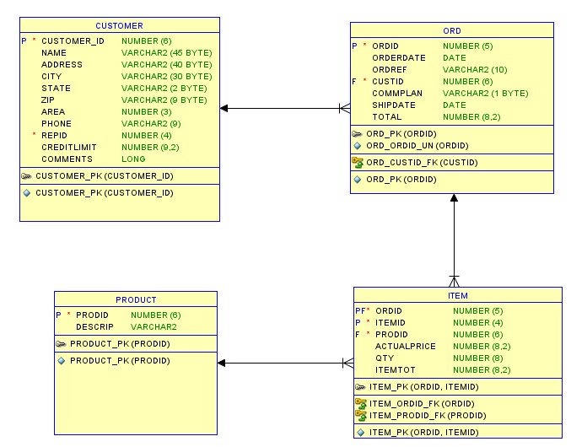

Note:

* Columns have been added to show how the database can be developed further.
* Primary Keys are labelled ‘P’.
* Foreign Keys are labelled ‘F’.
* Indexes have been added to speed up queries.

### Surrogate vs Natural Keys

Each table should have a primary key that uniquely identifies each row. A primary key can consist of one or more columns, containing either natural or surrogate values.

Note that you should never rely on the table’s ROWID as a key, as its value may change or be deleted.

Surrogate keys are preferred over natural keys. A surrogate key is a number generated by a sequence, and as such is guaranteed to be unique and will never change. Surrogate keys are numeric and can usually be stored more efficiently than natural keys, with string values.

**CREATE TABLE mytable (**

**mytableID INTEGER GENERATED ALWAYS AS IDENTITY,**

**description VARCHAR2(50),**

**PRIMARY KEY (mytableID) );**

A natural key has a real-world value, such as a National Insurance number, or a person’s last name. You cannot absolutely guarantee that a natural key will be unique, or that it will never change. If you have a very simple, small table, you may prefer to use a natural key for simplicity if its primary key values are static and unique. For example, a table of countries may have a primary key Country_Code with values such as “F” for France, “UK” for the United Kingdom etc.

A few reasons you may prefer to use a surrogate key:

* You notice column you wish to use as a key has ascribed meanings, e.g., “2022-ABC-0001”. Somebody could decide to change the structure of this value in the future.
* Your key would have multiple segments. Again, it could be decided to add more segments to the key in future, plus your SQL join statements are more complicated.
* There is a risk of duplicates, for example Last_Name would be a bad choice for a unique primary key.

The following example illustrates the use of a surrogate key.

**ORD**

|  |  |  |
| --- | --- | --- |
| **Column Name** | **Data Type** | **Description** |
| ORDID | NUMBER | Primary key (unique generated sequence number)  NUMBER GENERATED ALWAYS AS IDENTITY |
| ORDREF | VARCHAR2(10) | Free form reference e.g. FRED-A001 |
| ORDERDATE | DATE |  |
| CUSTID | NUMBER | Foreign key references CUSTOMER.CUSTID |

**ITEM**

|  |  |  |
| --- | --- | --- |
| **Column Name** | **Data Type** | **Description** |
| ORDERITEMID | NUMBER | Primary key (unique generated sequence number)  NUMBER GENERATED ALWAYS AS IDENTITY |
| ORDID | NUMBER | Foreign key references ORD.ORDID |
| ITEMID | NUMBER | Sequential line number 1,2,3 etc. |
| PRODID | NUMBER | Foreign key references PRODUCT.PRODID |
| ACTUALPRICE | NUMBER |  |
| QTY | NUMBER |  |

* ORDREF is not suitable for use as a key, as it contains user defined values that could easily be duplicated, or need to change.
* The primary key on each table consists of a single column containing a sequentially generated number.
* The Primary Key ORDERITEMID uniquely identifies each row on ITEM, and is a sequentially generated number with no direct relationship to the ORD table.
* The Foreign Key ORDID links the rows in ITEM with their corresponding ORD row.
* If you need a foreign key to ITEM on another table, you can use the ORDERITEMID column, instead of having to add two separate columns ORDID and ITEMID.

### Constraints

Use Database Constraints to enforce business rules for table columns.

Database constraints are stored in the data dictionary rather than in application code, and provide a simple to code, centralized method for enforcing business rules.

All applications that access the database must follow the rules defined in the data dictionary. If you build the rules into each application program you need to do a lot more work, the complexity is increased and inconsistencies and errors are more likely.

Examples:

|  |  |
| --- | --- |
| **Constraint Type** | **Description** |
| PRIMARY KEY | A column or group of columns that uniquely identifies a row in the table. No column in the primary key may be null, unlike a UNIQUE constraint. It may be preferable to use a surrogate key value instead of natural keys such as a name. Not mandatory. |
| FOREIGN KEY | Create a relationship between two tables. For example, ORDID on ITEM references ORDID on ORD. Prevents a row from being created on ITEM without a corresponding ORD (orphaned row). Improve performance when reading data. Insert/modify/delete slowed down, but maintains data integrity. You may omit foreign keys on audit or logging tables where you never want to delete the data in cascade. |
| UNIQUE | The data stored in the specified column, or group of columns, must be unique for the rows in the table. Columns may have null values. |
| NOT NULL | The column must contain a non-null value. |
| CHECK | The column must not contain a value that violates the specified condition, for example SALARY > 0 |

## Coding Standards

### Golden Rules for Software Development

1. Modular programming: separate the functionality of your programs into independent modules, or packages containing functions and procedures.
2. Each module should hide its implementation behind an interface that exposes its functionality. This is a key principle of software engineering.
3. Code for
   1. Correctness
   2. Maintainability
   3. Security
   4. Performance
4. Never repeat code. Write the code for each business function once, and call it from database triggers and application programs.
5. Do not hardcode literal values.
6. No GOTOs or unconditional branching. Every loop should have one way in, and one way out

### Naming Conventions

The following rules apply to database objects (tables, views, procedures) and PL/SQL variables:

* Maximum length 30 characters
* First character must be a letter
* Valid characters: letter, numeral, $, _, #
* PL/SQL is not case sensitive to identifiers

Note that the object names are stored in the database in uppercase, and are not case sensitive unless you surround them with double quotes.

#### File Names

|  |  |
| --- | --- |
| PL/SQL Package Specification | <packagename>s.pls |
| PL/SQL Package Body | <packagename>b.pls |
| PL/SQL library | <libraryname>.pll .plx .pld |

#### Database Objects

|  |  |
| --- | --- |
| Table Names | Singular description for example PRODUCT. For tables that resolve many-to-many relationships combine the names of each table |
| Views | <tablename>_<criteria>_V |
| Index Primary | <tablename>_IDX |
| Index Other | <tablename>_<column>_IDX |
| Constraint (Primary Key) | <tablename>_PK |
| Constraint (Foreign Key) | <table from>_<table to>_FK |
| Constraint (Not Null) | <tablename>_<column>_NN |
| Constraint (Check) | <tablename>_<column>_CHK |
| Constraint (Unique) | <tablename>_<column>_UN |
| Sequences | <tablename>_<column>_SEQ |
| Triggers | <tablename>_T[n] |

#### PL/SQL Variables and Identifiers

##### Prefixes

|  |  |
| --- | --- |
| l_ | Local variables |
| g_ | Global variables |
| v_ | Variable |
| c_ | Constant |
| p_ | Parameter |
| t_ | User defined type |
| tb_ | PL/SQL table |
| r_ | PL/SQL record |

##### Suffixes

|  |  |
| --- | --- |
| _cur | Cursor |
| _IN | Parameter Input |

### Coding Style

Make sure that your code is easily readable, and that its intended purpose is clear. Creating simple, elegant code is an art form, but it is well worth doing, as it makes future maintenance so much easier. Your code should practically document itself, but that is not to say that you should do away with comments and documentation altogether!

* Include useful comments that clearly explain what the program does, but only where necessary.
* Do not include comments for lines of code that are self-explanatory.
* Indent your code to make it readable, using spaces. Never use tabs as they may vary in width in different environments, messing up the formatting.

## PL/SQL Programming Tips

1. Do not put your code inside database triggers, instead call packaged functions and procedures from the triggers.
2. Thick database paradigm: SQL that manipulates data (select, insert, update, delete, merge, commit, rollback) should only be issued from a PL/SQL packaged function or procedure that resides in the database. Do not put this SQL code inside your application programs.
3. Create an error/exception handling package, and call this from your programs instead of hardcoding error messages in multiple places.
4. Avoid explicitly declared datatypes for your variables, instead use %TYPE to reference database columns.
5. For derived values, declare your own application types (SUBTYPE) in a Rules Package.
6. Define types that are not derived from table columns in a package, for example: *plsql_constants* so that they’re all in one place, and easy to change if required.
7. Avoid using *commit* as it is hardcoding, and compromises flexibility around testing
8. Implicit cursors may be faster than explicit cursors
9. Bulk Collect should be used in preference to cursor for loops
10. Use TOAD (Tool for Oracle Application Developers) PL/SQL Code Expert Review features. Available in version 8 onward.
11. Follow Oracle’s application development and customization standards

### Packages

By creating a specific object for each business process or function, you can maintain the logic in one place and re-use it many times. This is easier to maintain and saves a great deal of effort.

* Collect related procedures and functions together.
* Restrict public access to application logic.

### Functions

Do not hardcode business rules into your code – hide the implementation by creating a function to perform the necessary process.

***Example:***

Hardcoded rule to derive an employee’s full name.

**SELECT employee.first_name || ‘ ‘ || employee.last_name**

**INTO l_full_name**

…

Instead, create a function to derive the full name.

**SELECT employee_rp.fullname(first_name, last_name)**

**INTO l_full_name**

…

Here we call the function *employee_rp.fullname,* which takes first_name and last_name as parameters and returns the full name, formatted as required. The function is stored in a package named *employee_rp,* which is the rules package for handling employee data.

You would just need to alter the employee_rp.fullname function to implement business changes, rather than seeking out, and amending each instance of code in many different programs.

### Data Typing

Do not hard-code data-types in your programmes that will potentially cause future problems.

For example, a variable to hold a person’s name, set to a fixed length of characters. What if the associated column in the database is altered in the future and its new length exceeds your variable’s declared length?

Instead, base your variables on database columns wherever possible so that your programs stay in line with the underlying database structure.

**V_employee_name varchar2(100); -- WRONG**

**V_employee_name emp.employee_name%TYPE; -- BETTER!**

### Performance

#### Bulk Collect versus Cursor For Loops

Do not use a Cursor For Loop for a single row query.

With Oracle 8i and above, replace cursor FOR loops with the much faster BULK COLLECT query.

NB: From Oracle version 9i onward you can bulk collect into row type structures instead of individual tables for each field, but you cannot currently reference the individual fields within the FORALL process.

Bulk Collect avoids context switch between SQL engine and PL/SQL engine that embedded SQL statements cause – this is slow.

Take great care with this – Bulk Collect sacrifices memory for speed. All your collected data is stored in memory, and you then use FORALL to process the data. If you have tables with millions of rows Bulk Collect could cause severe memory problems.

To avoid this problem, code the Bulk Collect to work in manageable batches of rows, for example groups of 200.

#### Cursors

Implicit cursors are often faster than explicit cursors.

**SELECT employee.last_name**

**INTO l_last_name**

**FROM employees**

**WHERE employee_id = emp_id_in;**

Instead of:

**DECLARE**

**CURSOR c_emp IS**

**SELECT last_name**

**FROM employees**

**WHERE employee_id = emp_id_in;**

**Rec_emp c_emp%ROWTYPE;**

**BEGIN**

**OPEN c_emp;**

**FETCH c_emp INTO rec_emp;**

**IF c_emp%FOUND THEN**

**...**

**END**